DETERMINATION OF SCHOOL ADMISSION ARRANGEMENTS
FOR THE 2021-2022 SCHOOL YEAR

Notice is hereby given that the Ebor Academy Trust Board of Trustees, being the admission authority for all schools within the Trust have delegated the responsibility of determining the admission arrangements for the 2020-2021 to the LGB for school year for admission into

- The Reception Year of all Primary & Infant Schools within the Academy Trust
- Year 7 in all secondary Schools within the Academy Trust

Determination of the admission arrangements were made following consultation, as set out in The School Admissions Code and relevant legislation.

Copies of the determined admission arrangements are available for inspection at:
Ebor Academy Trust, The Leyes, Osbaldwick, York, YO10 3PR and on individual school websites or via the Trust’s website http://www.eboracademytrust.co.uk/ebor-hubs/ Information is also available on local authority websites.

Any person or body can object to the admission arrangements, where they provide their name and address, by writing to the school adjudicator, except where:

(i) the objection seeks, in substance, an alteration to admission arrangements for a grammar school;

(ii) the objection seeks, in substance, to remove selection from a selective Academy;

(iii) the objection relates to a non-increase in admission number for a school for which the local authority is not the admissions authority;

(iv) the objection relates to a non-increase in admission number for a community or voluntary controlled school, except where the objection is by the governing body of that school

(v) the objection relates to an existing agreement for the admissions arrangements of an Academy to vary from the School Admissions Code

(vi) the adjudicator has, within the last 2 years, made a decision to an objection to the admission arrangements of a school or Academy, and where any new objection referred to the adjudicator raises the same or substantially the same issues in relation to those admission arrangements.

All objections must be received by the adjudicator on or before 15th May 2020, at:
The Office of the Schools Adjudicator, Mowden Hall, Staindrop Road, Darlington, DL3 9BG
OSA.TEAM@osa.gsi.gov.uk Tel: 0870 0012468 Fax: 01325 391313

Signed: Becki Dean, Chair of Governors Dated: 27/02/2020

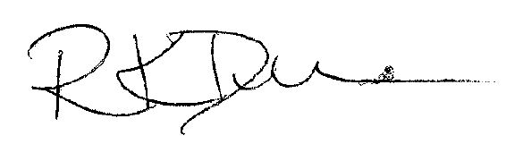

Copies of the School Admissions Code may be downloaded free of charge from the Department for Education website: https://www.gov.uk/government/publications/school-admissions-code--2

